Q4: Performs various operations on sets

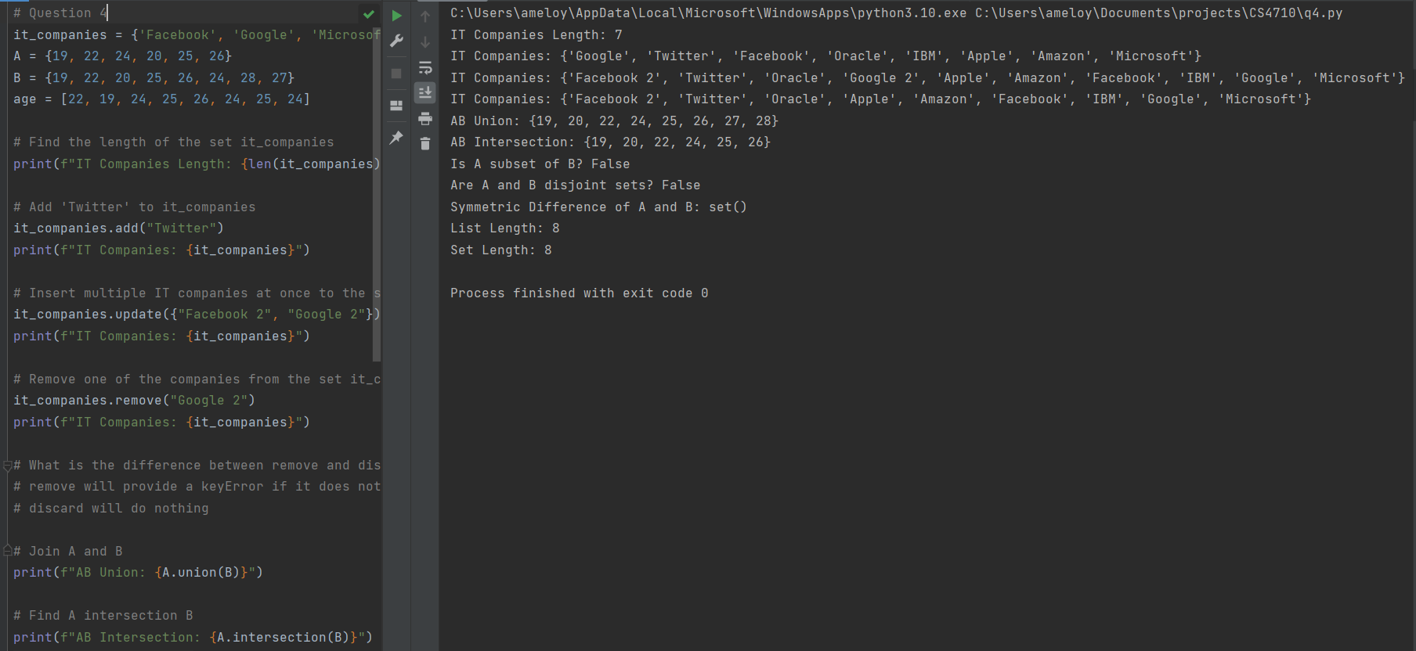

Q5: Find area and circumference of a circle, and take user input to find the area

Q6: Finds the unique words in a sentence

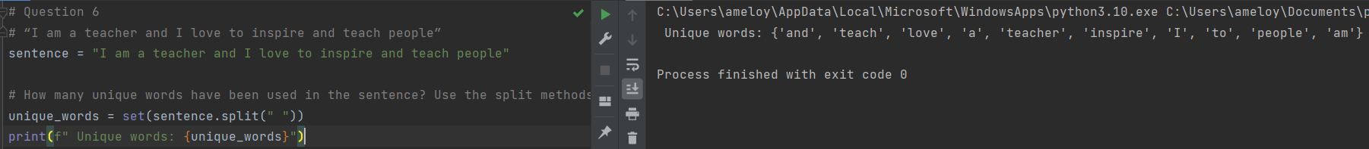

Q7: Prints two lines formatted with tab escape sequences

Q8: Formats a string to display the correct radius and area values

Q9: Convert a list of weights in pounds to a list of weights in kilograms

Q10:

The diagram below shows a dataset with 2 classes and 8 data points, each with only one feature value, labeled f.

Note that there are two data points with the same feature value of 6. These are shown as two x’s one above the other. Provide stepwise mathematical solution, do not write code for it.

1. Divide this data equally into two parts. Use first part as training and second part as testing. Using KNN classifier, for K=3, what would be the predicted outputs for the test samples? Show how you arrived at your answer.

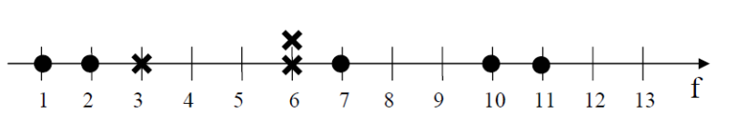

|  |  |  |  |  |
| --- | --- | --- | --- | --- |
| Training | Dot: 1 | Dot: 2 | Cross: 3 | Cross: 6 |
| Test | Cross: 6 | Dot: 7 | Dot: 10 | Dot: 11 |

D = training – testing

Select three nearest from all (red is furthest value)

|  |
| --- |
| 7 (Cross) |
| |7-1| = 6 (Dot) |
| |7-2| = 5 (Dot) |
| |7-3| = 4 (Cross) |
| |7-6| = 1 (Cross) |

|  |
| --- |
| 10 (Cross) |
| |10-1| = 9 (Dot) |
| |10-2| = 8 (Dot) |
| |10-3| = 7 (Cross) |
| |10-6| = 4 (Cross) |

|  |
| --- |
| 11 (Cross) |
| |11-1| = 10 (Dot) |
| |11-2| = 9 (Dot) |
| |11-3| = 8 (Cross) |
| |11-6| = 5 (Cross) |

|  |
| --- |
| 6 (Cross) |
| |6-1| = 5 (Dot) |
| |6-2| = 4 (Dot) |
| |6-3| = 3 (Cross) |
| |6-6| = 0 (Cross) |

2. Compute the confusion matrix for this and calculate accuracy, sensitivity, and specificity values

|  |  |  |
| --- | --- | --- |
|  | Cross | Dot |
| Cross | 1 - TP | 0 - FN |
| Dot | 3 - FP | 0 - TN |

Accuracy

$\frac{TP+TN}{P+N}$ = $\frac{1}{1+3}$ = 0.25 = 25%

Sensitivity

$\frac{TP}{P}$ = 1 = 100%

Specificity

$\frac{TN}{N}$ = 0 = 0%